MAJOR PROJECT ON

FURNITURE E-COMMERCE STORE BASED ON AUGMENTED REALITY

Submitted in partial fulfilment of the requirements of the degree of

(Bachelor of Engineering)

Supervised by **Prof. Bhavna Arora**

Under – taken by

**Syamantak**

**N.Dhavle**

**Chaudhary**

**Mohammed Qais**

**Khan Mohd Saif**

**Tabarkullah**



**Computer Engineering**

**Atharva College of Engineering**

**(2020-21)**

**DECLARATION**

I declare that this written submission represents my ideas in my own words and where others' ideas or words have been included, I have adequately cited and referenced the original sources. I also declare that I have adhered to all principles of academic honesty and integrity and have not misrepresented or fabricated or falsified any idea/data/fact/source in my submission. I understand that any violation of the above will be cause for disciplinary action by the Institute and can also evoke penal action from the sources which have thus not been properly cited or from whom proper permission has not been taken when needed.

-----------------------------------------

-----------------------------------------

-----------------------------------------

**Date: dd/mm/yyyy (Name and Signature of Students)**

**Project Report Approval for B.E.**

This project report entitled **“*Furniture e-commerce store based on Augmented Reality*”** by ***Syamantak Dhavle, Mohammed Qais & Khan Mohd Saif Tabarkullah*** is approved for the degree of  ***Bachelor of Engineering in Computer Engineering.***

Internal Examiner

---------------------------------------------

---------------------------------------------

External Examiner

---------------------------------------------

---------------------------------------------

Date: __________

Place: __________

College Seal



**AET’S**

**ATHARVA COLLEGE OF ENGINEERING**

CERTIFICATE

*This is to certify that*

**Syamantak N. Dhavle**

**Mohammed Qais**

**Khan Mohd Saif Tabarkullah**

*Have satisfactorily completed the requirements of the B.E Project Report*

On

**“FURNITURE E-COMMERCE STORE BASED ON AUGMENTED REALITY”**

*As prescribed by the* ***University of Mumbai*** *Under the guidance of*

Guide

**Prof. Bhavna Arora**

**Prof. Bhavna Arora Dr. Suvarna Pansambal Dr. S.P.Kallurkar**

**Project Coordinator Head(Computer Engineering) Principal**

**(April 2021) College Seal Date:**

**ACKNOWLEDGEMENT**

We would like to thank our project guide **Prof. Bhavna Arora** for her enormous cooperation and guidance. We have no words to express our gratitude for a person who wholeheartedly supported the project and gave freely of her valuable time while making this project. All the inputs given by her found a place in the project. The technical guidance provided by her was more than useful and made this a success. She has always been a source of inspiration for us. It was a great experience learning under such a highly innovative, enthusiastic and hardworking professor. We are also thankful to our principal **Dr. S.P. Kallurkar**, project coordinators and all the staff members of the Computer Department who have provided us various facilities and guided us throughout to develop this project idea. Finally, we would like to thank the teachers of our college and friends who guided and helped us while we were working on this project idea.

**ABSTRACT**

Electronic Commerce is a process of doing business through computer networks. A person sitting on his chair in front of a computer can access all the facilities of the Internet to buy or sell the products. Unlike traditional commerce that is carried out physically with effort of a person to go & get products, ecommerce has made it easier for humans to reduce physical work and to save time. E-Commerce which was started in early 1990’s has taken a great leap in the world of computers, but the fact that has hindered the growth of e-commerce is security. Security is the challenge facing e-commerce today & there is still a lot of advancement made in the field of security. The main advantage of e-commerce over traditional commerce is the user can browse online shops, compare prices and order merchandise sitting at home on their PC. For increasing the use of e-commerce in developing countries the B2B e-commerce is implemented for improving access to global markets for firms in developing countries. For a developing country advancement in the field of e-commerce is essential. The research strategy shows the importance of e-commerce in developing countries for business applications.

**INDEX**

|  |  |  |
| --- | --- | --- |
| **Sr. No.** | **Contents** | **Page No.** |
| 1 | Introduction | 6 |
| 1.1 | Need and Motivation | 7 |
| 1.2 | Basic Concept | 8 |
| 1.3 | Applications | 8 |
| 1.4 | Market Potential and Competitive advantages | 8 |
| 2 | Review of Literature | 9 |
| 3 | Report on the Present Investigation | 12 |
| 4 | Aim and Objectives | 13 |
| 5 | Problem Statement. | 14 |
| 6 | Proposed System | 15 |
| 7 | Requirement Analysis | 16 |
| 7.1 | Functional Requirement | 16 |
| 7.2 | Non-Functional Requirement | 16 |
| 8 | Scope and Feasibility | 17 |
| 9 | Design Details | 18 |
| 9.1 | Context Level diagram | 18 |
| 9.2 | DFD Diagram | 19 |
| 9.3 | Sequence Diagram | 20 |
| 9.4 | E-R Diagram | 21 |
| 10 | Implementation Plan | 22 |
| 10.1 | Hardware Requirements | 22 |
| 10.2 | Software Requirements | 22 |
| 10.3 | Timeline | 23 |
| 11 | Methodology | 24 |
| 12 | Conclusion | 26 |
| 13 | Acknowledgement | 27 |
| 14 | Literature Cited | 28 |

**LIST OF FIGURES**

|  |  |  |
| --- | --- | --- |
| **Figure No.** | **Name of Figure** | **Page No.** |
| 6.0 | System Representation | 15 |
| 9.1 | Context Level Diagram | 18 |
| 9.2 | Data Flow Diagram | 19 |
| 9.3 | Sequence Diagram | 20 |
| 9.4 | Entity Relation Diagram | 21 |
| 10.1 | Tentative Timeline | 23 |

**LIST OF TABLES**

|  |  |  |
| --- | --- | --- |
| **Figure No.** | **Name of Table** | **Page No.** |
|  |  |  |
|  |  |  |
|  |  |  |
|  |  |  |
|  |  |  |
|  |  |  |

**1. INTRODUCTION**

The modern home decor and furniture lessens your stress after spending with a hectic schedule at the office. As vast changes have occurred in the furniture world, many innovative startups are accommodating to the huge demand.

The online marketplace of India is expected to grow to $14.5 billion (Rs 88,921 crore), and online furniture share of retail is likely to go up by 2021.

In the beginning, except a few organized players like Home Stop, and HomeTown; none other brands in the furniture retail space have controlled to create a large chain of stores. But, a group of online furniture marketers has come out in the last few years, providing new business models for a company which is certain to grow as India’s middle-class broadens and spending hikes.

Now, platforms like Pepperfry, Urban Ladder, and FabFurnish have become the most successful eCommerce portals of India as they drive the latest market and assisting people to furnish their homes.

1.1 Need and motivation

There’s a definite need for a technical solution for this problem since the furniture e-commerce industry, as of now, appears to be growing but soon there will be a need for a breakthrough in technology which can replace the touch and feel factor involved for the customers while buying furniture in order to reduce their hesitation while buying such high ticket and larger-sized products online.

Motivation for developing an application like this is to introduce a new technology factor to the already existing e-commerce platforms, which due to the widespread adoption of e-commerce are becoming increasingly common.

1.2 Basic Concept

The basic concept is to build an android e-commerce application with AR functionality. Our goal is to build an app which will provide the customers with an option to check the eligibility of a certain product with their needed specifications, which will involve factors such as dimensions & colour schemes.

1.3 Applications

1. Prospective furniture customers can use this application to gain more insight towards the actual product description.

2. Existing Furniture e-commerce websites & applications can include this technology to boost sales.

3. The technology can be further extended to be used in other industries such as textiles, electronics etc.

1.4 Market potential and Competitive advantages

This product has a range of applications across various industries, which gives it a competitive advantage over the traditional furniture stores. Since the application uses AR as a tool to provide a better shopping experience to customers, it should be accepted widely by the market. Moreover, since the other shopping apps do not have a functionality that is as optimum as this app, it provides us with yet another competitive advantage.

**2. REVIEW OF LITERATURE**

1. ARKit and ARCore in serve to augmented reality [1]

In this paper we have seen the basic understanding about the open-source libraries to be used in building this project, their main features and functionalities for a better implementation in the real world.

2. “Mobile Augmented Reality Survey: FromWhere We Are to Where We Go –IEEE Access” [2]

This paper introduces the concept of MAR (Mobile Augmented Reality) and provides the basic understanding about the same. It also provides the reader with the categorization of the application fields together with some representative examples. It also introduces the reader to the user interface and experience in MAR applications and continues to describe the core system components of the MAR systems.

3. E-commerce Smartphone Application ((IJACSA) International Journal of Advanced Computer Science and Applications,)[3]

This paper provides a new perspective on the types of applications that can be used for e-commerce. It describes and analyses device requirements, provides a review of important aspects of mobile devices that can use such applications and the requirements of websites designed for m-commerce. The design and security aspects of mobile devices are also investigated. As an alternative to existing m-commerce applications, this paper also investigates the characteristics and potential of the PhoneGap cross-mobile platform application

4. ‘‘Creating open source repository of 3D models of laboratory equipments using Blender” IEEE-2010

In this paper we are provided with the key design goals and are presented a methodology to create a repository of 3D models. This methodology can be used to create a significant number models in Blender in less amount of time. These models can be downloaded and directly used by anyone. Anyone can use this methodology to create their own model repository.



5. “Capabilities of ARCore and ARKit Platforms for AR/VR Applications” - International Conference on Dependability and Complex Systems. In this paper ARCore and ARkit capabilities are scrutinized and compared. Authors establish comparison criteria for both platforms, provide the example of test applications and results of comparison tests. Obtained results can be a help in choosing the right framework to speed up prototyping and development of modern AR/VR applications. This paper consists of a comprehensive comparison of said new frameworks in the following respects: general performance (CPU/memory use), mapping of planes on various surface types, influence of light and movement on mapping quality etc.

6. “The Use of ARCore Technology for Online Control Simulations” IEEE 2020

The paper describes an educational mobile application that controls the 3D model of towercopter using augmented reality for smartphones. The app is developed using the ARCore technology that allows insertion of 3D objects into a real space via smartphone or tablet. The application serves as a simple guide for a real device which is placed in a laboratory and enables to create simulations based on user input data. The application interface is connected with Scilab API simulation module that provides data for 3D model animations. Users can set their own controller parameters into the predefined control structures. Application is a part of virtual laboratory and can help students with understanding of problems connected with the education process.

7. “Android Application Development using Android Studio and PHP Framework” [5]

In this paper “Android Application Development using Android Studio and PHP Framework” The author described that this era is very great and exciting for mobile developers. Android supplies a well-off application structure that permits you to develop imaginative applications and amusements for android cell phones utilizing Java dialect condition. Android proposes a brought together approach for application advancement on cell phones which implies that engineers require produce for the Android, and their applications ought to have the capacity to keep running on various gadgets controlled by Android.

8. “Web AR: A Promising Future for Mobile Augmented Reality—State of the Art, Challenges, and Insights” IEEE 2019

This paper differentiates between hardware-based mobile AR and app-based Mobile AR. It describes how hardware-based Mobile AR implementation is known to be costly and lacks flexibility, while the App-based one requires additional downloading and installation in advance and is inconvenient for cross-platform deployment. It provides the advantages of Web-Based AR implementation than hardware based AR by providing information that webAR is a lightweight and cross-platform service provisioning platform. It also discusses the emergence of 5G mobile communication networks and it’s potential to enhance the communication efficiency of Mobile AR dense computing in the Web-based approach.

9. “Systematic review and meta-analysis of augmented reality in medicine, retail, and games” Springer 2020

This paper presents a detailed review of the applications of augmented reality (AR) in three important fields where AR use is currently increasing. The main focus if this paper was to highlight how AR improves and enhances the user experience in entertainment, medicine, and retail. The authors briefly introduce the topic of AR and discuss its differences from virtual reality. They also explain the software and hardware technologies required for implementing an AR system and the different types of displays required for enhancing the user experience.

10. “Research on Development of Android Applications” IEEE 2011

This paper introduces the Android platform and the features of Android applications, giving a detailed description of the Android application framework from the perspective of developers. A simple music player is provided as an example to illustrate the basic working processes of Android application components. This paper provides the required insight to understand the operation mechanism of Android applications to help develop applications on the Android platform.

**3. REPORT ON PRESENT INVESTIGATION**

There are multiple existing applications based on furniture e-commerce like UrbanLadder, Homecentre & Pepperfry. For this particular study, we will analyze the Pepperfry application.

Features

Features of this application are -

* Sign up/Login with social media websites as well as phone number verification.
* Decent user interface.
* Furniture products are well categorized.
* Multiple product images.
* 2d Product view in AR.

General working of the current system -

The end user has to download the application from google play store/Apple app store. Upon opening the application for the first time, it requests login information and provides the user the option to register their account if they haven’t already registered. Upon successful login, the application displays categories of furniture and the user can select the product colours, product images and can even check a 2d model of the product with their ar enabled device cameras.

Limitations

1. 2D representation of the product does not offer a comprehensive idea of the product. 2. Representation of the product in a 2D manner in AR feels overall cheap.

3. Products delivered may be different from the ones in the image as they are displayed in a fancy manner in the images.

4. High prices of the products makes the customer hesitant while completing checkout.

5. High probability of product returns.

6. The problem described in point 2 might also cause the brand image of any furniture store to be tarnished.

3.1 Comparison of present and proposed systems

|  |  |  |
| --- | --- | --- |
| **References** | **Positives** | **Negatives** |
|  |  |  |
|  |  |  |
|  |  |  |
|  |  |  |
|  |  |  |
|  |  |  |
|  |  |  |
|  |  |  |

Table 3.1 Comparative study of present investigations

**4. AIM AND OBJECTIVES**

4.1 Aim

Our aim is to create the most realistic rendition of the furniture products present in the e-commerce store. We plan to import the objects created to Android studio and create an app which includes an e-commerce store with AR functionality. This app will provide users with a more accurate representation of the said products and will reduce the rate of returns, thereby saving shipping costs. It also provides the user with a substitute (to a certain degree) for the touch and feel aspect while buying furniture, which also increases their trust in the store.

4.2 Objectives-

* Use of this application will enable the user to visualize how the furniture would look in the real world, offering preview of furniture in one’s real environment.
* By the usage of this application, the furniture sellers can win competitive edge in the market.
* It also aims to prevent revenue loss to the business, spoilt brand image of the store, customer attrition and deterioration of stakeholders’ interests as the customers can try visualizations of furniture placements in the available space before purchasing them.
* It aims to put the sentence “What you see is what you get” in practice.

**5. PROBLEM STATEMENT**

Purchasing products for interior design is a challenging task. The problem is concerned with the fact that the product cannot be put into its place before it is purchased. Customers may wonder how the furniture would look in its tentative place, People end up buying furniture with incorrect dimensions, inaccurate colours or different designs from the ones that they see in the product images. This creates a problem for customers as returns in such online stores is also a hassle and generally a bad idea, since it is not easy to ship furniture due to the high prices involved in shipping. Visualizing the furniture in the real world can be made possible through Augmented Reality applications.

**6. PROPOSED SYSTEM**

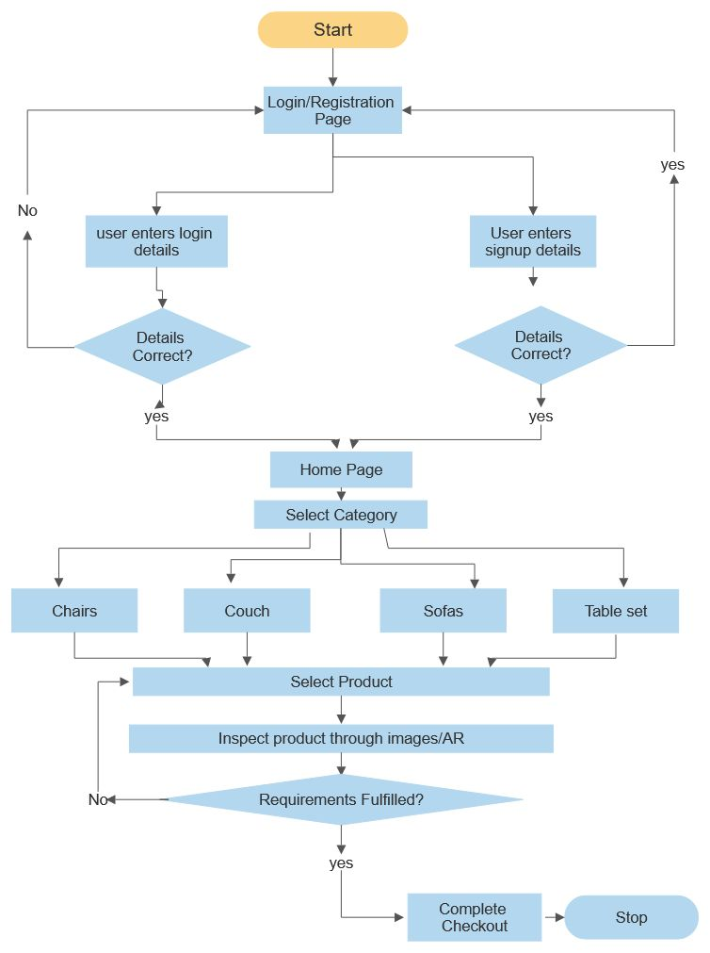

Figure 6.0: System Representation Flowchart

Explanation

* After the application is downloaded from the play store, the user will be greeted with the login/registration page.
* If the user has an existing account, he/she will be able to login with their respective credentials. If the user is not registered, he/she can enter their information to signup/register.
* Upon successful login, the user will be greeted with the home page. The home page will consist of Categories of furniture from which the user can choose from. When the user selects a category, he/she will be provided with a list of products from that specific category.
* The user can then check if the product meets their requirements of certain factors such as colour/size/designs from the images and will also be able to check the layout of the particular product through their cameras on their AR enabled mobile devices.
* After the user is convinced about the product specifications and other requirements, the user can place their orders by choosing any of the payment options available in the application.
* Upon successful completion of the checkout process and capturing the payment, the order will be delivered to the customer within said number of days.

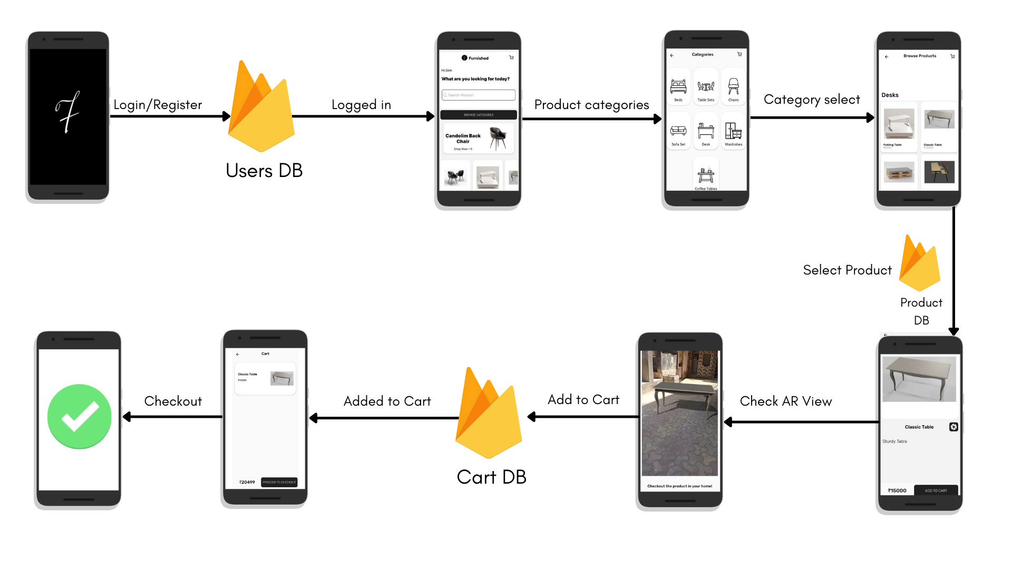

Fig 6.1 User Block Diagram

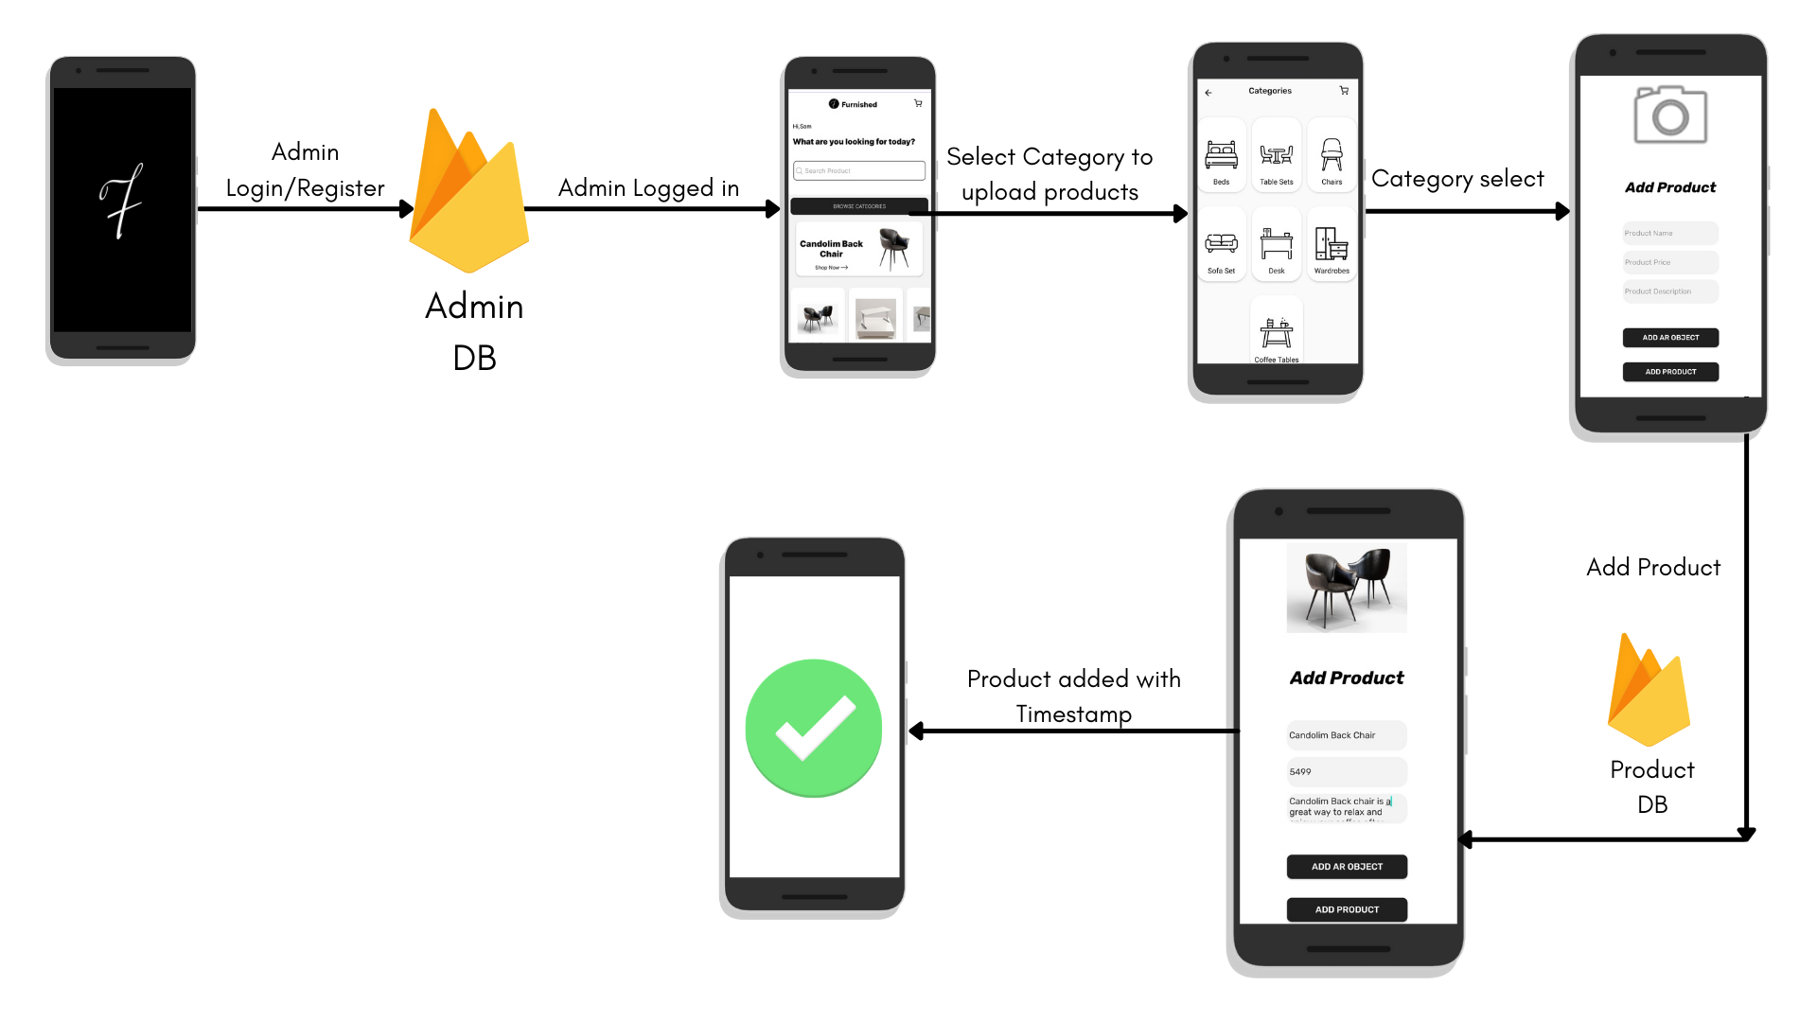

Fig 6.2 Admin Block Diagram

Explanation

* Products can be added to the application only by the administrator.
* To add the product the admin must login with the phone number & password already present in the database.
* Upon successful login, the admin will be greeted with a categories screen from which he/she can select the category of the product to be uploaded.
* After selecting the appropriate category, the admin will be able to add the product name, price, description/specifications, image & Ar models in GLB format.
* After the required data is entered, the user can press the add product button to add the product to the database, where he/she will receive a notification about the product being uploaded.

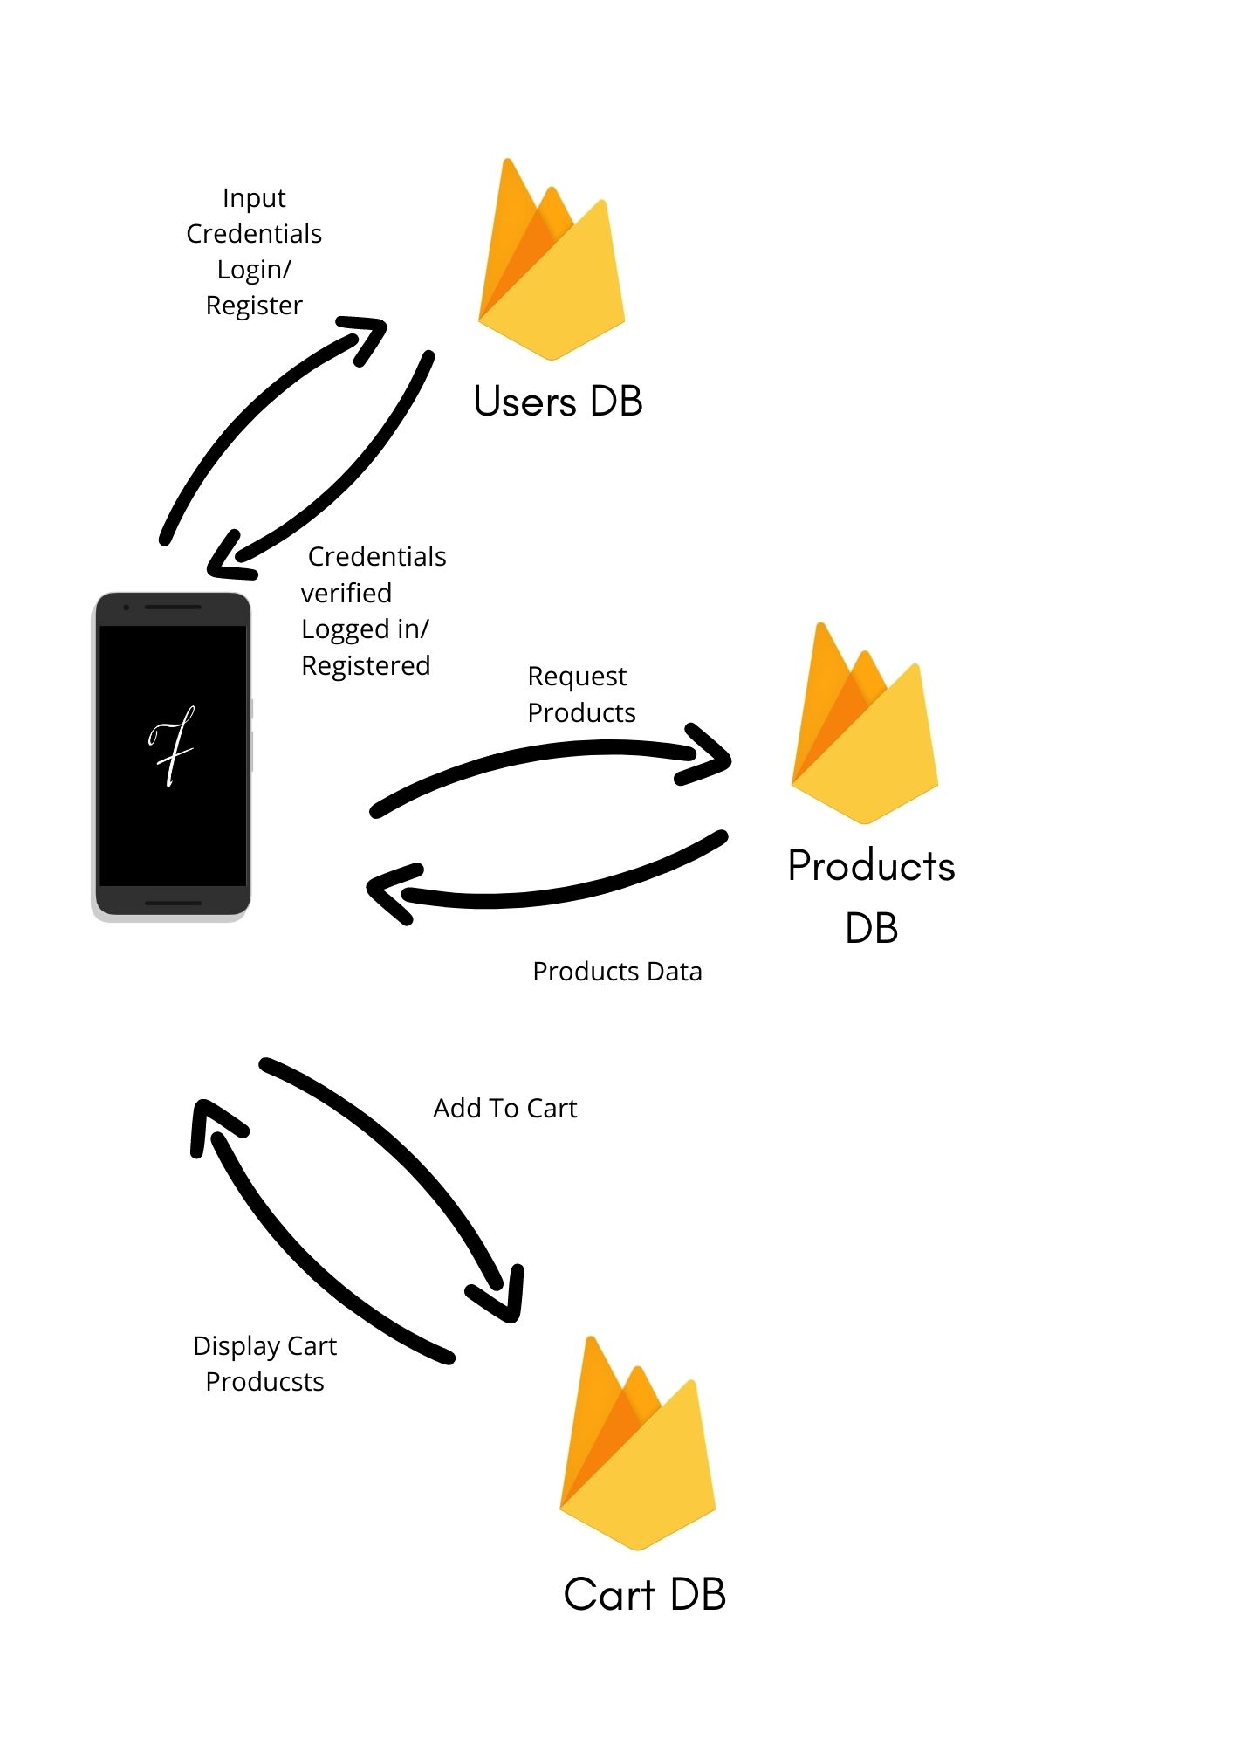Fig 6.3 System Database Representation

6.1 Components of the system

* Android Device with ArCore Support

AR core is the platform around which AR applications are built. These applications involve the use of cameras with good quality image sensors, since better quality of the cameras and sensors provide for better tracking ,scaling and general movement of the AR objects in the application.

* Realtime Database & Storage from Firebase.

The application needs a database to be linked to, in order for it to save its data on a server, and in todays’ day Firebase seems to be the best option for it since it has an easy implementation and coding process, is relatively fast & free for a certain amount of data used.

* Sceneform Plugin

The Google Sceneform Tools plugin is designed to help you work with 3D assets and the Sceneform SDK to build AR apps in Android Studio. It requires Android Studio versions 3.1 and above. It has a simple and convenient asset import flow Asset viewer, so you can see how your assets look before you deploy. It also automatically configures gradle dependencies.

* Ar Core -

It is the most important component of our system on which the application is built. It is also known as Google Play Services for AR & is a software development kit developed by Google that allows for augmented reality applications to be built on multiple platforms.

**7. REQUIREMENT ANALYSIS**

7.1 Functional Requirements

This section focuses on the functional requirements of the project. Functional requirements are the mobile devices required, the bandwidth requirement for user & products data transmission, data storing and manipulation techniques. Since the project is mainly built for android devices, the prime functional requirements are android devices with AR support and good quality cameras and their associated image sensors.

7.2 Non-Functional Requirements

Non-functional requirements can help to improve the quality of the product, but their absence will not affect the implementation. These include LIDAR sensor, which is a sensor primarily created for better autofocus in iPhone devices, but also drastically improves the quality of the ar objects perceived. Moreover, if faster databases are used for the application, we can also reduce the lag at runtime where the model is built.

**8. SCOPE AND FEASIBILITY**

8.1 Scope

The proposed system has a wide application. Due to increase in online shopping, the proposed system has wide applications, especially in cities like Mumbai, Delhi and Bangalore. Give your shopper a true sense of your product with augmented reality. Let your customers interact with your computer like never before for a better buying experience.

8.2 Feasibility

8.2.1 Operational Feasibility

Operational feasibility is the ability to handle operations and supervise the process for any additional manual analysis. Most of the things will be automated and software-based hence, a single person can manage to inspect over a wide network with minimal effort.

8.2.2 Technical Feasibility

Technical feasibility involves implementing the proposed system in real-life scenarios. The popularity of Augmented Reality (AR) is increasing day by day, hence programming communities are equipped with the latest libraries, which can be directly implemented in the software. Depending upon the requirement, minor modifications can be done, but overall, the existing system is quite scalable to the proposed problem without many technical obstacles.

8.2.3 Economical Feasibility

Economic feasibility is the capital centred approach. It considers the estimated cost and statistical look out of a project. The Software required for this project are expensive, the money needed to spend on this part is significantly important. On the other hand, computer devices with some minimum requirements are mandatory, but without knowing the exact configuration of current systems, it's difficult to estimate the tentative cost required for upgrades (if any).

8.2.4 Legal Feasibility

Legal feasibility is an assessment that investigates whether any aspects of proposed system conflicts with legal requirements or any laws. Since this project is based on e-commerce & a technology that has not been used in this particular niche, dealing with legal feasibility would be a small hindrance. It is important that the project or business is following the requirements needed. including business license, patents, copyrights, certificates, tax numbers etc.

8.2.5 Schedule Feasibility

Schedule feasibility is defined as the probability of a project to be completed within its scheduled time limit. As this is an optimization system, the more time invested in enhancing the ar models and the application ui will result in the application or idea being widely accepted across various niches, since ar is not used for mainstream applications yet, but for more entertainment centered applications.

**9. METHODOLOGY**

9.1 Model Generation / Collection

There are many ways in which the models required for this project can be generated. One can try to create the models based on real furniture by using softwares like Cinema 4d, Blender etc. Since this project uses sceneform library, we propose to use glb models since they can be packed along with all of it’s textures and colours. Moreover, they have a faster efficiency of building at runtime itself. For example purposes, we have taken some pre built open source models along with the ones that we built and used them in our application. In the future, the model generation process can be done by using a technique called Photogrammetry, which uses high definition cameras along with their sensors to create the most apt 3d model of the object in question.

9.2 UI Building

User interface is a very important aspect of this application since any customer who is an online shopper should have a pleasant experience of shopping online, which is what we are trying to achieve overall with Augmented Reality. The UI of the application is built around a similar project on a ui designing tool called Figma. The design of all the pages of the application are done on android studio itself, but the colour schemes, fonts, placement of icons, logos, cards and other elements are inspired from the e-commerce open source project on figma.

9.2.1 Modules in the application -

The application consists of multiple applications. They are mentioned below in the order of flow of control.

* Login/Registration - There are 2 modules in the app which can register the user. One of them can login or register a user and the other allows the app user to login as an administrator. For security purposes, there is no functionality for anyone to register themselves as an administrator. The admin credentials can only be generated at the database, which in this case is the firebase realtime database.
* Products - Products are added via the application itself, though they can also be added through the database. The admin is the only person authorised to add products, the admin can simply login, select the category of the product in which they want to upload their products & after entering the required data and after adding the ar object, the admin can simply press the add product button to upload it to the database. The product is added with a timestamp as it’s product id, which consists of the date on which it is uploaded, as well as the time. For eg - Apr 06, 202113:53:47 PM
* Ar View of the products - Ar objects are located in a separate folder called product AR files in the firebase storage database. While uploading, their name is set to their product id’s as above, appended at the end with a .glb just in case there is some error which renames the file while uploading. The file is fetched with it’s product id and a temp file is created, from which a model is built and displayed into the AR fragment.
* Cart - A product can be added to cart using the ‘add to cart’ button at the bottom of the product details page. Once the button is pressed by the user, the product is automatically added to cart due to its unique product id. The product will be added to a separate node called the cart view in the firebase database along with the id of the user who has added the product to cart. The product can also be removed from the cart by the ‘cart options’ menu.

**10. DESIGN DETAILS**

The design part includes the following:

a. Context Level Diagram

b. Data Flow Diagram (DFD)

c. Sequence Diagram

d. Entity Relation Diagram

e. Database design

f. Storage design

10.1 Context Level Diagram

The context level diagram represents the entire system as one high-level process and shows the relationship between different entities involved in the process. The entities involved in this project are described in the following diagram, namely, System Administrator, End user or Customer & Furnished application system/database.

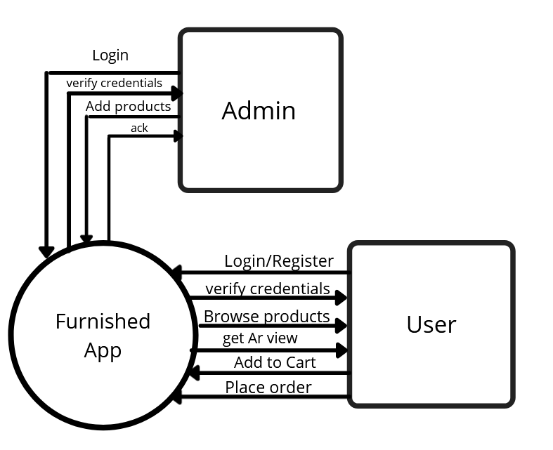

Figure 10.1: Context Level Diagram

10.2 Data Flow Diagram

A data flow diagram (DFD) maps out the flow of information for any process or system. It uses defined symbols like rectangles, circles and arrows, plus short text labels, to show data inputs, outputs, storage points and the routes between each destination. Data flowcharts can range from simple, even hand-drawn process overviews, to in-depth, multi-level DFDs that dig progressively deeper into how the data is handled. They can be used to analyse an existing system or model a new one.

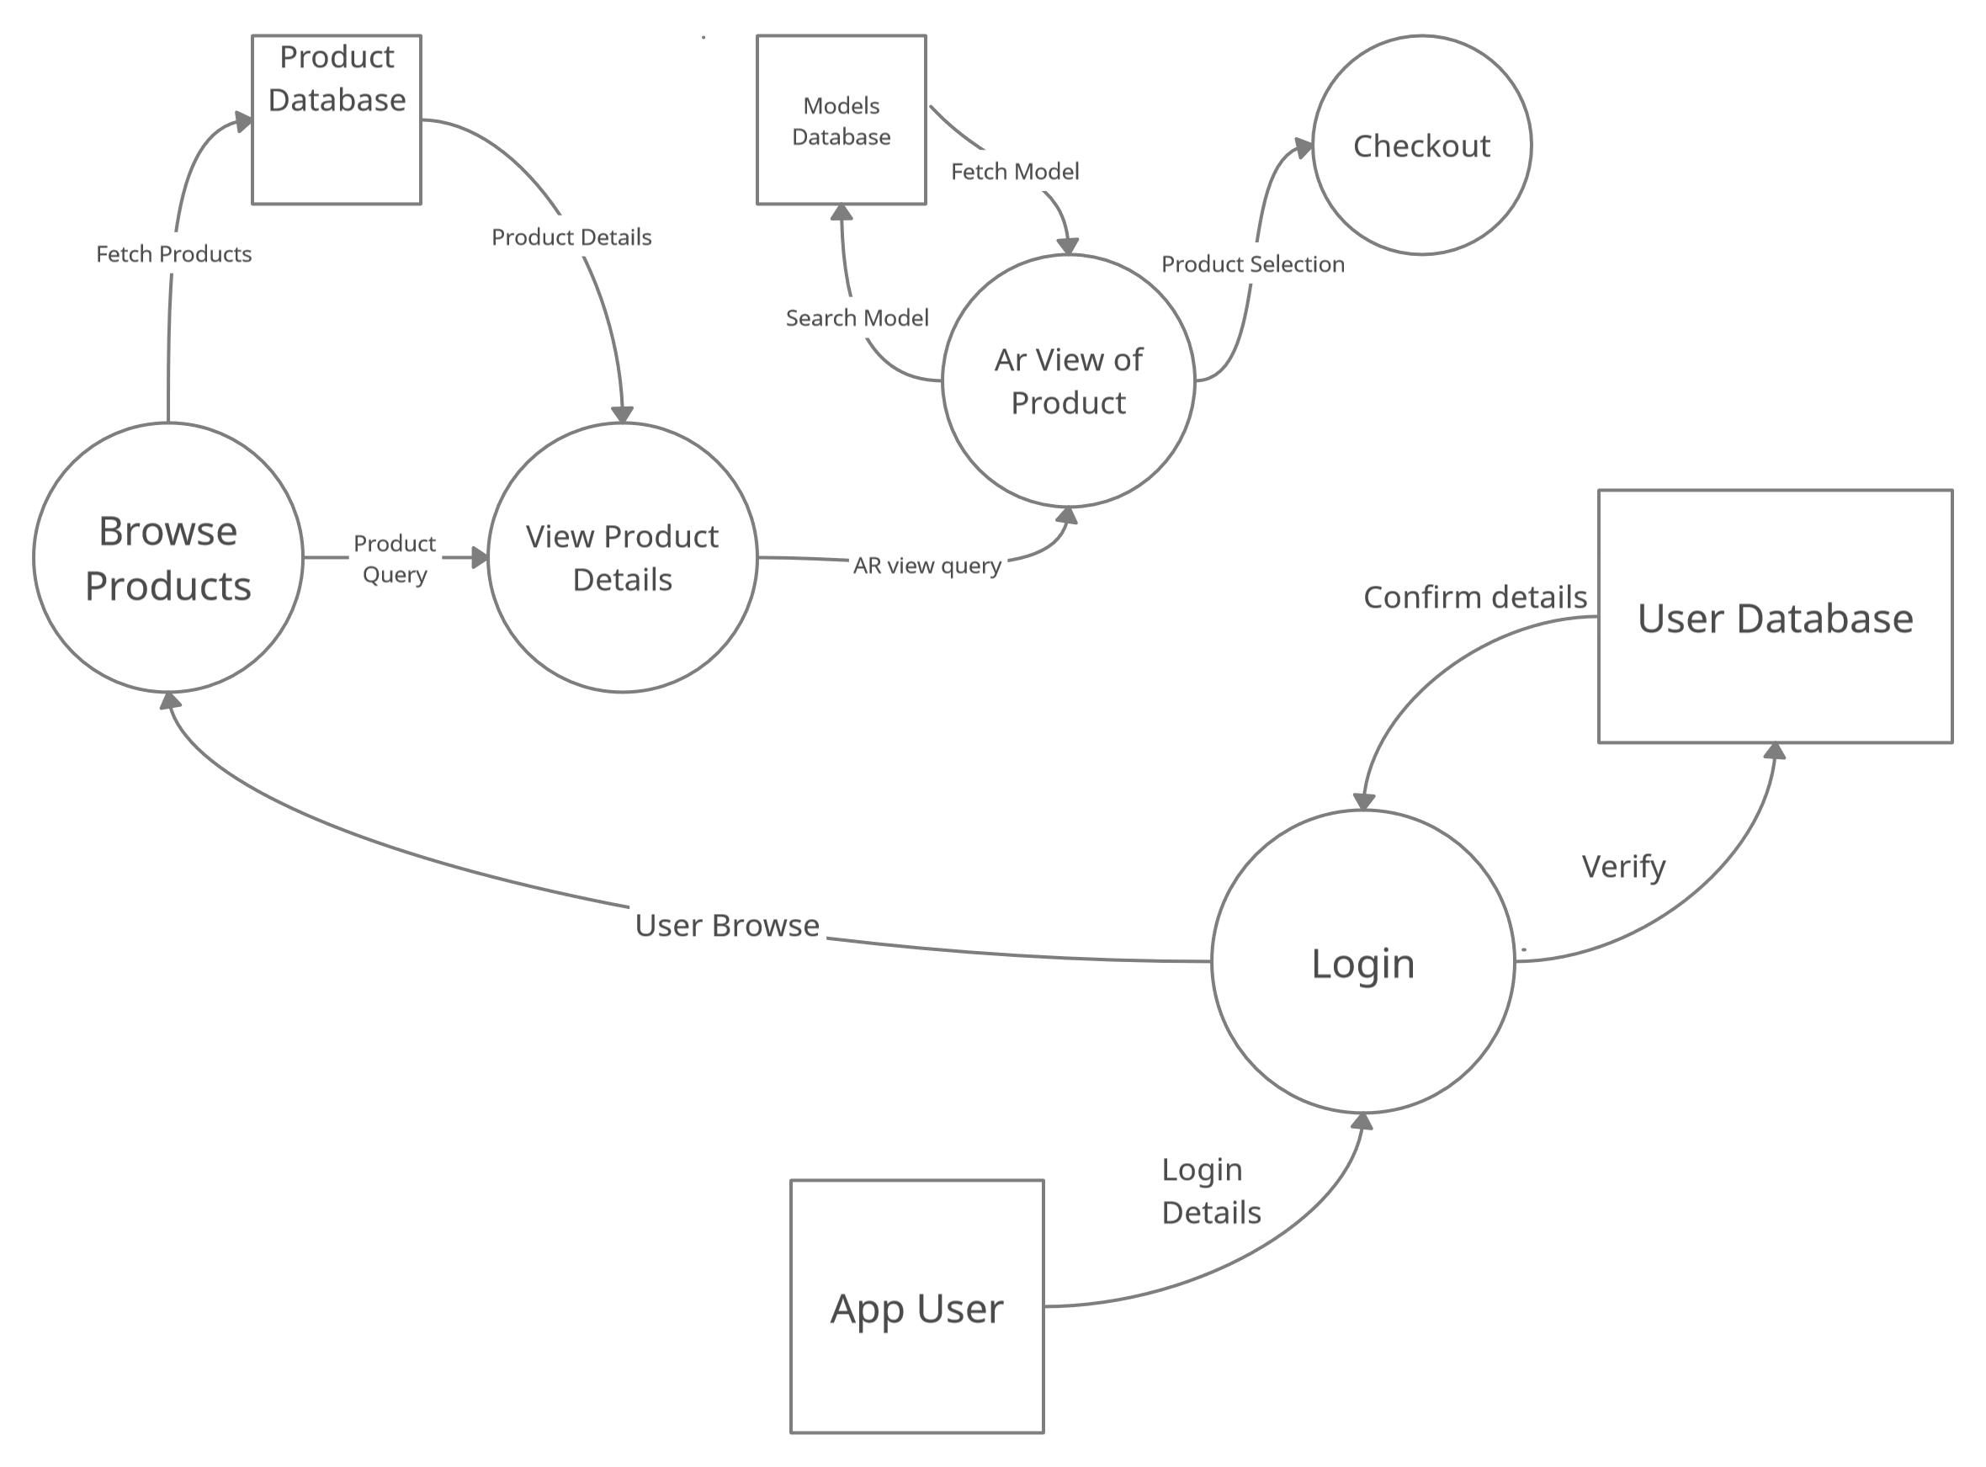

Figure 10.2: Data Flow Diagram

10.3 Sequence Diagram

In the sequence diagram, the objects according to their time of execution are listed below. The sequence diagram deals with how the user will flow through the system sequentially and what are the processes that will take place. As seen in the figure, there are multiple get and post requests taking place to the database for access to the UI as well as the product information.

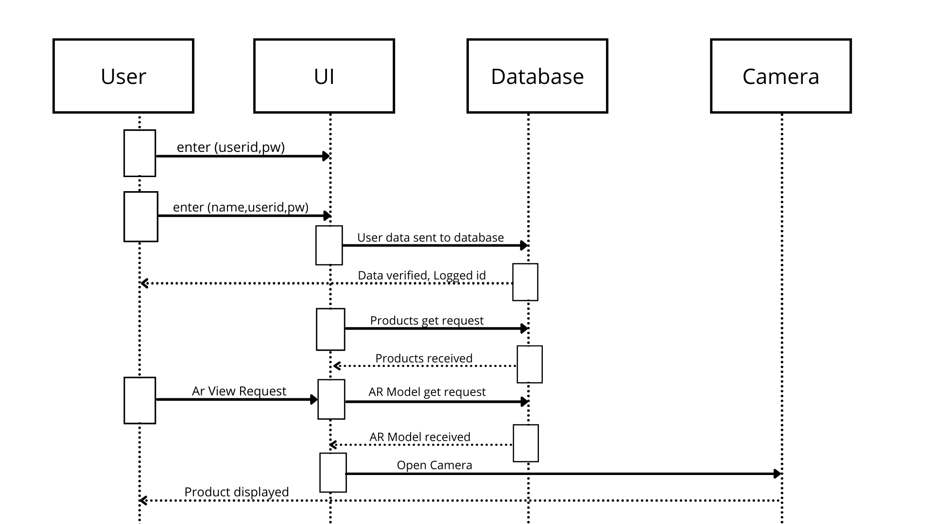

Figure 10.3: Sequence Diagram

10.4 Entity Relation Diagram

The main entities and how they are related to the other is shown in the diagram below. The entities and their key attributes are defined and what entities are interacting with each other for what purposes.

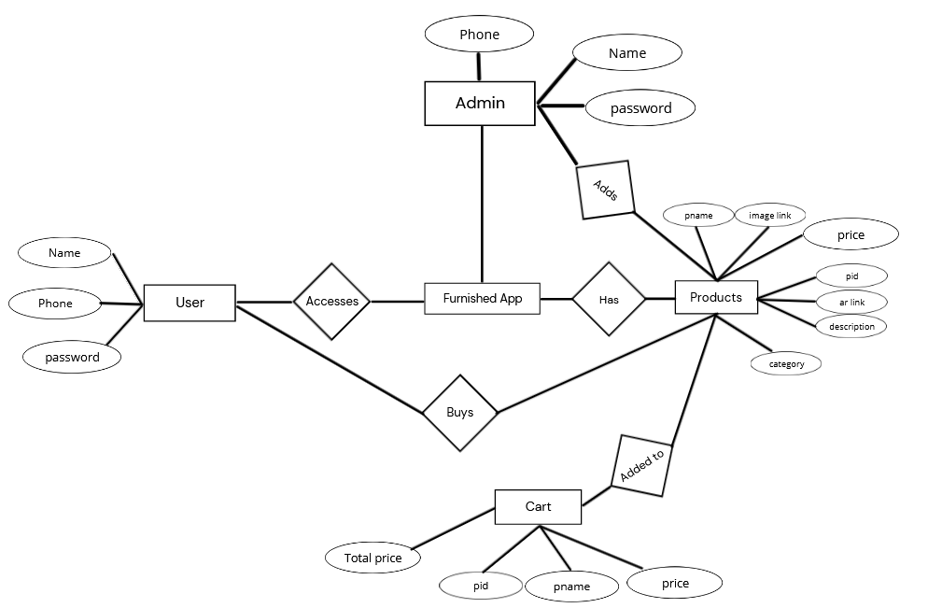

Figure 10.4: Entity Relation Diagram

10.4 Database Design

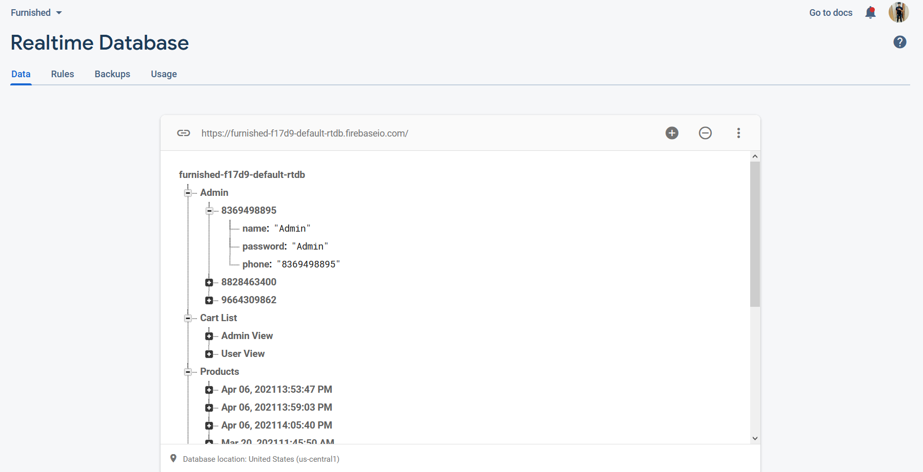

Overall Database Design

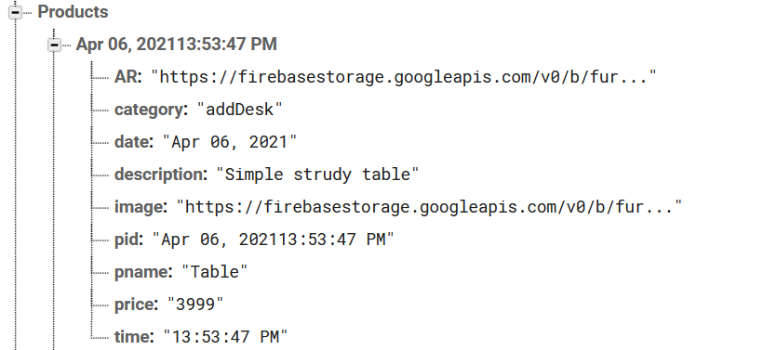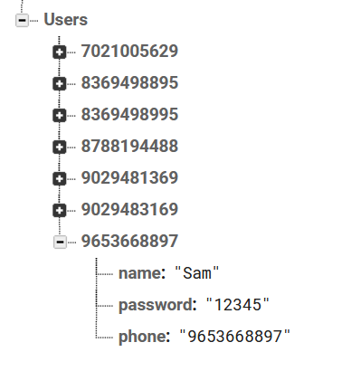

Products Node

Users Node

Figure 10.5: Database Design

10.4 Database Storage

Figure 10.5: Database Storage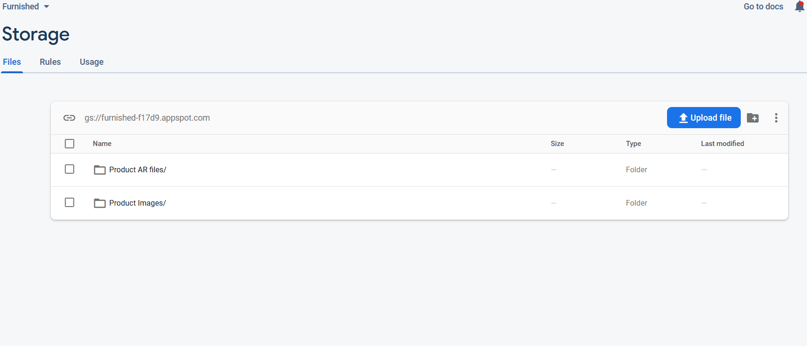

**11. IMPLEMENTATION AND EXPERIMENTAL SET UP**

11.1 Hardware Requirements

Operating Systems: Windows 10 or Ubuntu

System RAM: 8 GB

System ROM: Preferably cloud storage or 1TB per slot

System GPU: Minimum GTX 710 or equivalent, Recommended GTX 1650 or higher

System Processor: Intel i5 or higher

Bandwidth Requirement: 5.0 GHz up to 1GBPS transmission rate

11.2 Software Requirements

Programming language/Environment: Android Studio 3.6.3 and above , minimum Target api 24

Gradle Dependencies: ARCore, Sceneform, Firebase, Picasso, recyclerview, cardview

* Database: Firebase
* Language: Java , XML
* Designing Tools: Adobe Photoshop, Figma, Canva

11.3 Operational Requirements

Paid Databases like AWS, Google Cloud Storage or Firebase with Spark plan.

High Quality android cameras with great autofocus sensors

Apple iphone 12 with Lidar sensor

Photogrammetry equipment for extremely high quality 3D models.

11.4 Dataset and Connectivity

11.4.1 Dataset used

Microsoft COCO: Common Objects in Context [18]

The dataset is created by gathering images of complex everyday scene containing common objects in their natural state. Objects are labelled using per-instance segmentations to aid in precise object localization. The dataset contains photos of 80 objects class that would be easily recognizable by a 4-year-old. With a total of 2.5 million labelled instances in 328k images.

11.4.2 Implementation platform

Google Colab [19]

Colaboratory, or “Colab” for short, is a product from Google Research. Colab allows anybody to write and execute arbitrary python code through the browser, and is especially well suited to machine learning, data analysis and education. More technically, Colab is a hosted Jupyter notebook service that requires no setup to use, while providing free access to computing resources including GPUs.

11.4.3 Framework Used

Darknet [20]

Darknet is an open-source neural network framework written in C and CUDA. It is fast, easy to install, and supports CPU and GPU computation.

11.4.5 Object Detector

YOLOv4 [11]

Yolo_v4 is a Convolutional Neural Network based state-of-the-art object detector.

11.5 Pseudo Code

11.5.1 Implementing Object Detection on Google Colab

***Import*** required dependencies like matplotlib, opencv, numpy

***Import*** training dataset (COCO)

***Import*** darknet framework

***Import*** suitable convolutional weights

***Enable*** GPU on the colab notebook

***Verify*** the CUDA cores

***Create*** Darknet directory in session storage

***Select*** Images for training and validation along with required weights

***Set*** training parameters for model

***Train*** model

***Run*** model on required Image/ Video

11.5.2 Enabling Camera Capture on Google Colab

***Import*** required dependencies like display, javascript, b64decode

***Import*** camera-capture snippet from code snippets

***Select*** an input source for camera

***While*** (camera == active)

***Show*** camera output

***OnPress*** of Capture button

***Return*** current frame

***break***

11.5.3 Designing optimal algorithm for traffic signal timers

***Import*** python dependencies like Numpy, Matplotlib

***Create*** a 3D matrix of size (n, 4, 4)

***Initialize*** first instance of matrix

***Create*** four list s1_list, s2_list, s3_list, s4_list ( one for each signal lane in a classic 4-lane junction )

***Randomize*** each list with ‘n’ entries

***Define*** signal_timing function:

***If*** ( threshold_1 < detected_obejcts < threshold_2):

***Return*** ( green_signal_timer , 0)

***Elseif*** ( detected_objects > threshold_2):

***Return*** ( green_signal_timer, detected_objects – threshold_2)

***Append*** data from random_list to 3d_matrix

***For*** each data ***in*** 3d_matrix:

current_count = data + remaining_vehicle[data-1]

[Green_signal, remaining_vehicles] = Signal_timing(current_count)

***Display*** 3d_matrix

11.5.4 Average waiting time calculations at each signal  
***create*** two empty list named *signal_list* and *waiting_time_list*

***For*** current_count ***in*** 3d_matrix:

***For*** x ***in*** range of (current_count):

Signal_list.append([1,0])

***If*** (len(signal_list) < = max_permitteed_count):

***For*** x in signal_list:

X[1]+=1

temp_set = [x[1] for x in signal_list]

       temp_set = list(set(temp_set))

      waiting_time_list.append(temp_set)

       signal_list.clear()

***elif*** (len(signal_list)>(maxi[count,n,2]*2)):

***for*** x in signal_list:

         x[1]+=1

       temp_set = [x[1] for x in signal_list[:(maxi[count,n,2]*2)]]

       temp_set = list(set(temp_set))

       waiting_time_list.append(temp_set)

       signal_list = signal_list[(maxi[count,n,2]*2):]

     count+=1

waiting_time_list = list(np.concatenate(waiting_time_list).flat)

waiting_time_list = [int(x)*m for x in waiting_time_list]

average = sum(waiting_time_list)/len(waiting_time_list)

***return*** average

11.5.5 Average Number of Vehicles at each signal calculations

avg_vehicle_ideal = [sum(s1_list), sum(s2_list), sum(s3_list), sum(s4_list)]

avg_vehicle_dyn = [sum(s1_total_vehicles), sum(s2_total_vehicles), sum(s3_total_vehicles), sum(s4_total_vehicles)]

avg_vehicle_std = [sum(s1_total_vehicles_std), sum(s2_total_vehicles_std), sum(s3_total_vehicles_std), sum(s4_total_vehicles_std)]

avg_vehicle_ideal = [x/n for x in avg_vehicle_ideal]

avg_vehicle_dyn = [x/n for x in avg_vehicle_dyn]

avg_vehicle_std = [x/n for x in avg_vehicle_std]

11.6 Timeline

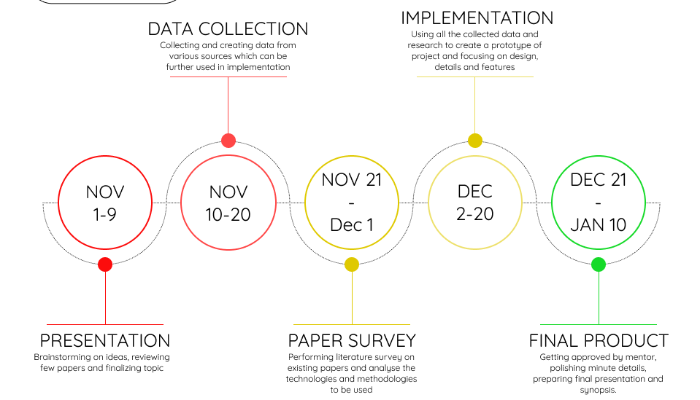

Figure 10.6: Tentative Timeline

11.7 Simulation and Working Environment

**12. TESTING**

12.1 Verification Testing

12.1.1 Framework Testing

We are using the Darknet framework for our object detection model. By cloning the open-source repository of ‘darknet’ available on GitHub we can import the framework in our system.

Command: !git clone https://github.com/AlexeyAB/darknet

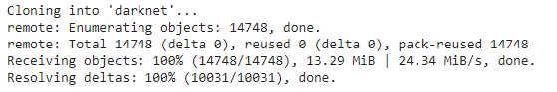

12.1.2 GPU & OpenCV Testing

Having a GPU enabled on Colab notebook is crucial for this system to run. By enabling GPU not only the training time will reduce substantially but also the accuracy of model will increase. On the other hand by default OpenCV is not fully operational on cloud platform hence we have to explicitly create a file to make use of python library to it’s full extent.

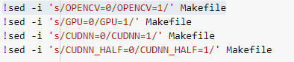

12.1.3 CUDA Verification

‘Compute Unified Device Architecture (CUDA)’ is a way in which you can achieve parallel computing and yield most out of your GPU power in an optimized way, which results in much better performance while executing tasks.

Command: !/usr/local/cuda/bin/nvcc --version

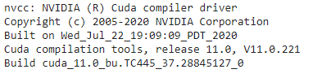

12.1.4 Darknet Verification

After cloning the framework, next thing is to deploy the framework on our system so that we can access its executable files and make required changes as per our need.

Command: !make

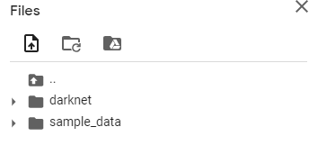

12.1.5 Yolov4 weights verification

Weights are backbone of the system. Using pre-trained weights, we can customize our object-detector as required. Weights decide how much influence the input will have on output.

Command: !wget https://github.com/AlexeyAB/darknet/releases/download/darknet_yolo_v3_optimal/yolov4.weights

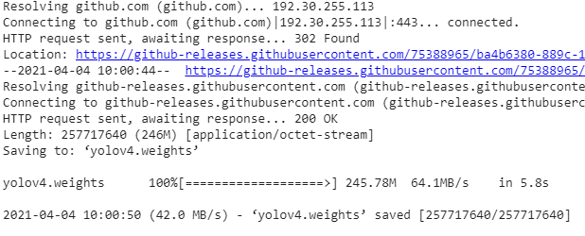

12.1.6 Camera Detection

Camera works as the source of acquiring images for further processing. Here we have used Smartphone camera for demonstration purpose.

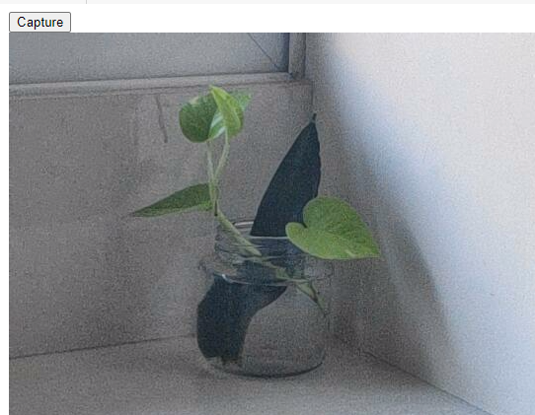

12.1.7 Algorithm Testing

In order to test the proposed algorithm, we have created a classic 4-lane junction scenario. In the following image,

Column1 represents the total number of vehicles present at that signal.

Column 2 represents the Red Signal Time allotted to that signal.

Column 3 represents the Green Signal Time allotted to that signal.

Column 4 represents the remaining number of vehicles after Green signal is over.

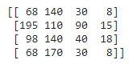

12.2 Validation Testing

The validation testing is used to evaluate a given model. In object-detectors we use this testing to fine-tune the model hyperparameters. Hence the model occasionally sees this data, but never does it Learn from this. We use the validation test results, and update higher level hyperparameters. So, the validation set affects a model, but only indirectly. The validation test is also known as the Dev test or the Development test. This makes sense since this dataset helps during the development stage of the model.

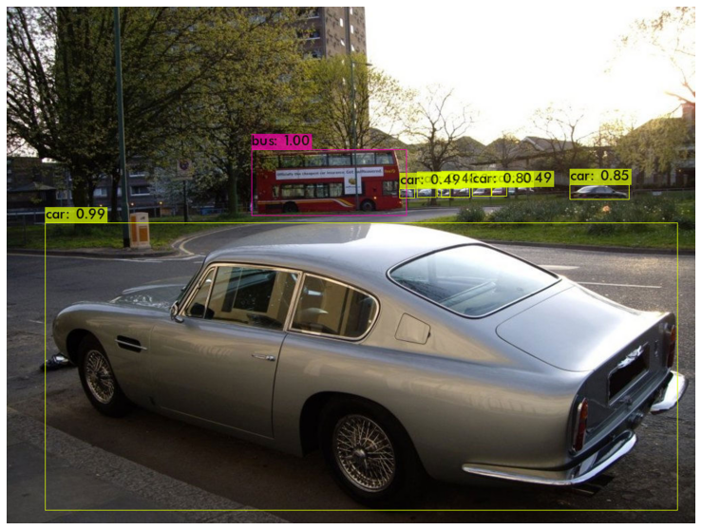

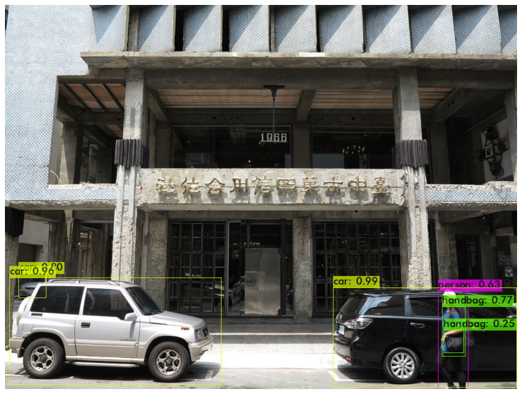

12.3 Test Cases

|  |  |  |  |  |
| --- | --- | --- | --- | --- |
| Test ID | Test Scenario | Expected Outcome | Actual Outcome | Pass / Fail |
| 1 | Single Object Detection | Detector should be able to identify object and label it correctly | Detector detected the object and labelled it correctly. | Pass |

Test Data



Outcome

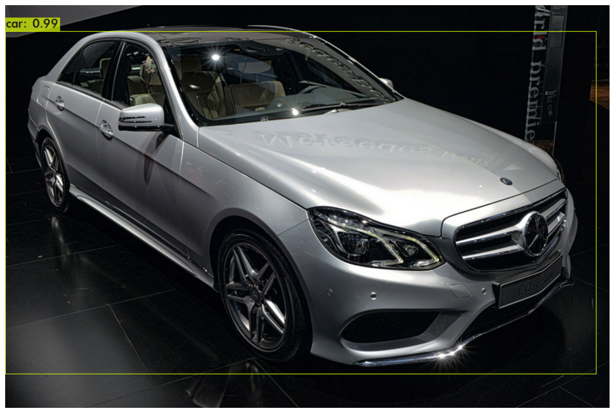

|  |  |  |  |  |
| --- | --- | --- | --- | --- |
| Test ID | Test Scenario | Expected Outcome | Actual Outcome | Pass / Fail |
| 2 | Single Class  Multi Object Detection | Detector should be able to identify multiple object and label it correctly | Detector detected multiple objects and labelled it correctly. | Pass |

Test Data



Actual Outcome

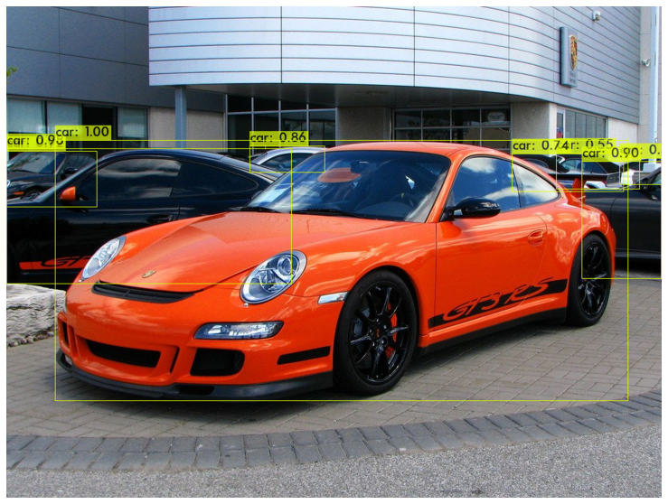

|  |  |  |  |  |
| --- | --- | --- | --- | --- |
| Test ID | Test Scenario | Expected Outcome | Actual Outcome | Pass / Fail |
| 3 | Multi Class  Multi Object Detection | Detector should be able to identify multiple objects of different classes and label it correctly | Detector detected multiple classes objects and labelled it correctly. | Pass |

Test Data



Actual Outcome

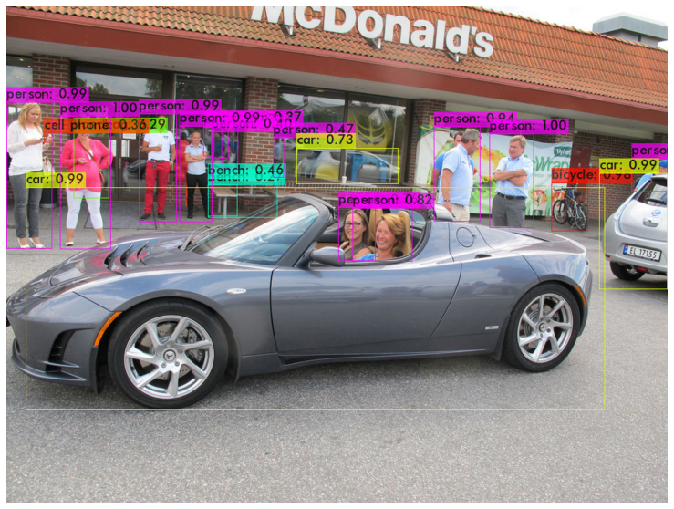

|  |  |  |  |  |
| --- | --- | --- | --- | --- |
| Test ID | Test Scenario | Expected Outcome | Actual Outcome | Pass / Fail |
| 4 | Multi Class  Multi Object Detection in a real-time video | Detector should be able to identify real-time objects of different classes in a video. | Detector detected real-time objects accurately. | Pass |

Test Data

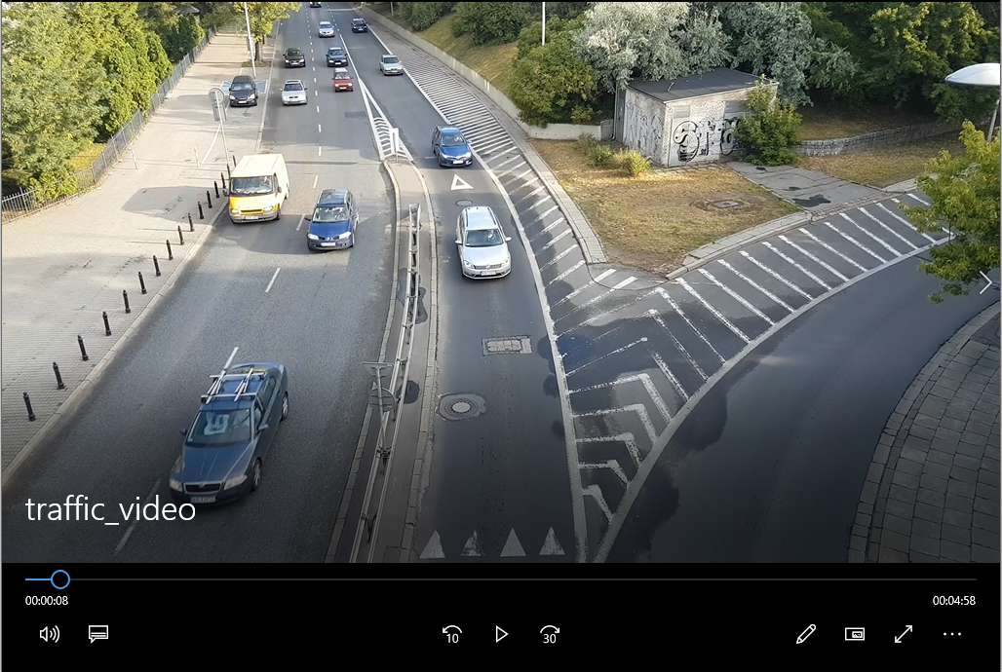

Actual Outcome

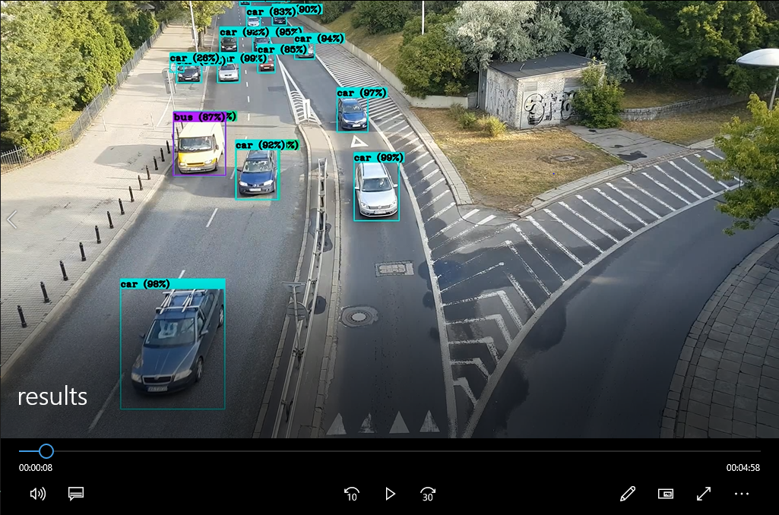

|  |  |  |  |  |
| --- | --- | --- | --- | --- |
| Test ID | Test Scenario | Expected Outcome | Actual Outcome | Pass / Fail |
| 5 | Traffic Signal Algorithm Testing over 50 iterations. | Remaining vehicles at the end should be as least as possible. | Vehicles at the end of test were lesser as compared to standard method. | Pass |

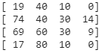 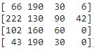 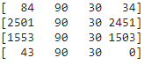

Initial Condition Final Iteration Final Iteration

Proposed Method Standard Method

**13. RESULT ANALYSIS**

13.1 Number of Queued vehicles

Number of queued vehicles is a parameter to identify the congestion at each signal by the end of 50 iterations. As seen in the charts below, in the standard method traffic density keeps on increasing after congestion occurs but in the proposed method the density does not differ marginally. Hence, it proves that proposed system can efficiently manage the same amount of traffic without causing long queues.

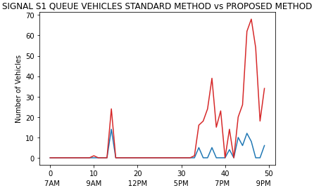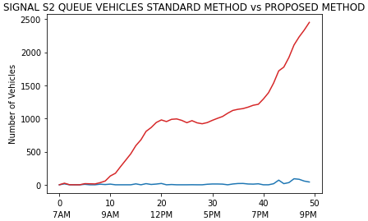

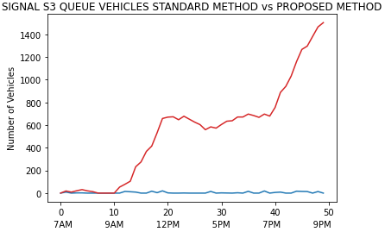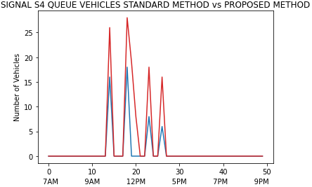

---------- Standard Method

---------- Proposed Method

13.2 Green Signal Duration

Green Signal Duration is the data collected during each iteration. As per the proposed system the algorithm will consider vehicle count at each signal and adaptively assign a green signal timer. As shown in the following charts at less congested signals like S1 & S4, considering the traffic density present at those signals the algorithm will allot less opening time. Similarly, at high volume signals like S2 & S3 the opening window time increases so that majority of vehicles present at that junction can pass through the signal.

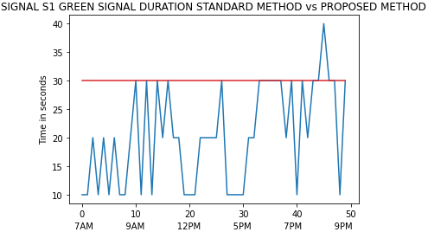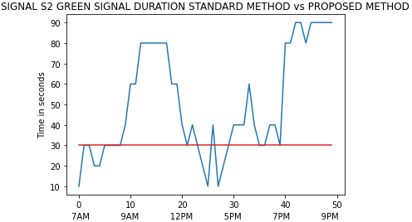

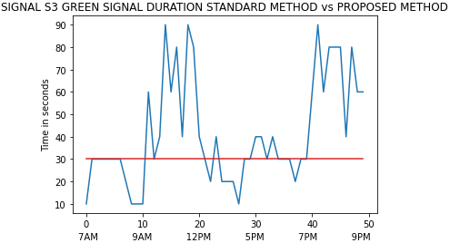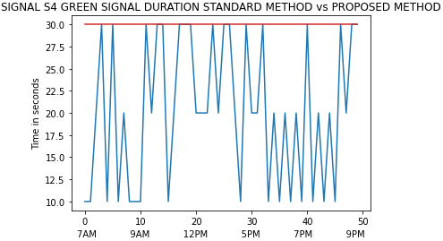

---------- Standard Method

---------- Proposed Method

13.3 Red Signal Duration

Red signal duration is the amount of time vehicles has to stop at each signal for the next turn. As shown in the diagram rather that providing same red signal for each interval our algorithm dynamically changes the window size such that maximum number of vehicles can pass through without causing congestion. For Signals S2 & S3 we can observe that for many instances the red signal duration dropped below the threshold to allow maximum vehicles to pass through that signal without causing congestion. Similarly, for S1 and S4 Red Signal Duration is fluctuating above and below the threshold line in order to maintain the balance. In a nutshell, the system borrows green signal time and assign it to high density lanes and similarly takes waiting time from congested lanes and assign it to less volume streets.

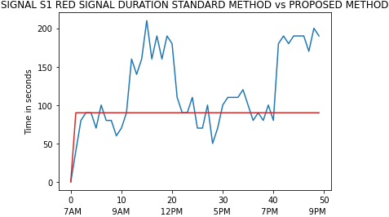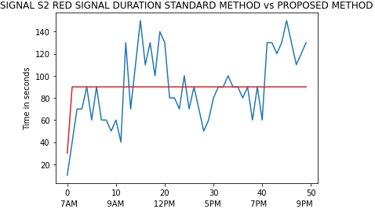

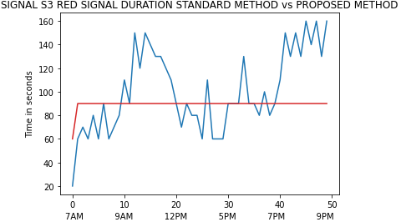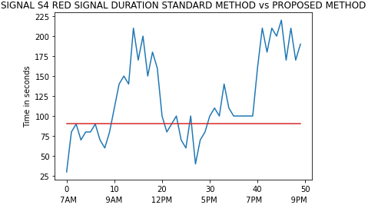

---------- Standard Method

---------- Proposed Method

13.4 Average Waiting Time

Average waiting time is the time that each vehicle has to spend at every signal. Average Waiting Time is an important parameter for this system as the ultimate goal is to reduce it as much as possible. In less congested lanes waiting time is not an issue but as the traffic increases the duration people have to wait at each signal also increases. As seen in the chart below for the signals S1 and S4 where traffic density is relatively less the average waiting time is less but as the traffic increases overtime and at its peak when congestion occurs, this waiting time increases substantially. But this is not the case in proposed system. Although, average waiting time at S1 and S4 in proposed system is relatively more, the same at other two signals it is considerably less, which is a trade off we can afford to have.

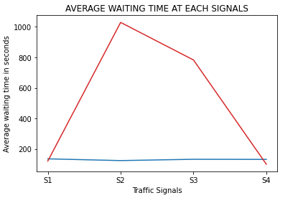

---------- Standard Method

---------- Proposed Method

13.5 Average Clearing Time

Average clearing time is the time required to clear the entire lane. In other words, it is time required for all vehicles present in the system to pass from each signal. This parameter will help us to decide whether the system is actually efficient or not. As seen in the chart below it takes about two and a half hours just to clear the traffic in existing lane for signal S2. However, that is not the case in the proposed system. The time required to clear the densest lane is the least. On the contrary for other two lanes S1 and S4 this time has increased by about 20 minutes. By changing few parameters and equipping the algorithm with more suitable dataset we can adjust the line so that it becomes homogeneous for all four signals.

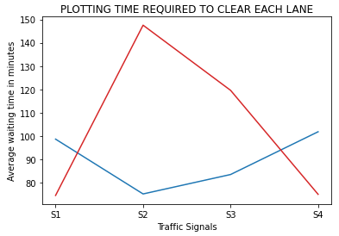

---------- Standard Method

---------- Proposed Method

**14. ADVANTAGES AND LIMITATIONS**

14.1 Advantages

* It’s been said that technology isn’t inherently good or bad, it’s how we use it that determines if it’s a detriment or a boon to society. In terms of Augmented Reality – the next big thing – we are seeing lots of benefits in the ways we live our everyday lives.
* Look around your home, the office, and the store and you will see lots of applications for AR. Augray is front and center of the AR experience helping companies to use all of these everyday occurrences as places to market and advertise products, services, and brands.
* Imagine you’re on a trip to a new city. Of course, you will want to find the best pizza, a bookstore, and the train station so you can get to your next destination. Using your AR device, scan a street sign or landmark and soon you will be on your way. No more wandering around aimlessly or asking for directions.
* With selfies and videos filling up Facebook feeds, AR will only improve the way we express ourselves. We are already sharing what we’re having for dinner or video clips from a baseball game or concert. As AR advances, we will use [social media](https://www.digitaltrends.com/cool-tech/5-awesome-ways-augmented-reality-could-improve-your-life/2/) sites to bring people to where we are, show what we’re doing and imagine who we are with.
* Staying healthy is important to a lot of people as they watch what they eat and try to exercise more. Suppose you’re at the grocery store looking at your favorite cereal and wonder if it’s good for you. With AR, you can easily see ingredients and product information at your fingertips without fiddling with the box.

14.2 Limitations

* While we at [ARinMED](http://arinmed.com/) are firm believers in the potential of augmented reality in all fields of medicine, we’d be irresponsible to blindly advocate for it without recognizing its limitations. Augmented reality, like all technology, has both pros and cons. We spend a lot of time on the pros–because there truly are so many! But today, we wanted to talk about some of the cons. There are things it can’t do, and there are legal pitfalls. Not everything is possible, at least, not yet, and this is especially true in the field of surgery. From its ancient origins in trepanation to the modern day operating room, the surgical field is constantly incorporating new and exciting technologies into its practice, and AR is surely one of them. However, despite all the things that AR can do, there are also a lot of things that it cannot.
* Since this is an object-detecting system, the computational requirements are quite high and might not be suitable for a normal computer system. Hence, making an upgrade in term of processing power could be proves an expensive but valuable investment.
* A significant disadvantage of augmented reality is that it requires the collection, generation, and analysis of large sets of data. Thus, similar to the [drawbacks of Big Data](https://www.konsyse.com/articles/the-pros-and-cons-of-big-data/), it is also haunted by issues concerning privacy and security.
* The game Pokémon Go demonstrated the drawbacks of AR. Because it adds virtual information to the natural environment, AR can hide cues in the real world. Some of these cues naturally help individuals avoid dangers. Nevertheless, the technology can make an individual less vigilant about his or her surroundings.

**15. APPLICATION AND FUTURE ENHANCEMENTS**

15.1 Application

* Although its popularity has waned since 2016, "[Pokemon Go!](https://interestingengineering.com/pokemon-go-will-give-players-rewards-for-picking-up-trash)" still has its die-hard fans. But the main part of this game's appeal was the way it combined the real world with favorite Pokemon characters.
* Augmented reality is now used in medical training. Its applications range from MRI applications to performing highly delicate surgery.
* The retail sector is also starting to use AR to help its customers have a more enjoyable and interactive shopping experience.
* Porsche has been trying out AR as a new method to help mechanics during servicing and maintenance of its customers' 'pride and joy'.

15.2 Future Enhancements

* Facebook CEO Mark Zuckerberg said that the company was planning to release its first pair of AR or augmented reality glasses in 2021 which could accelerate the spread of next-generation technology. Further, AR is being inducted in the field of Defence, Artificial Intelligence , Training, and Teaching, Consumer Entertainment, Travel, and Tourism, Automobile, etc.
* The Augmented Reality predictions for 2021 say that AR technology will continue to grow and pick up its pace and break all the headlines. Augmented Reality’s Evolution is Really Progressing AR is one of the types of technologies and initially began in the year 1968 by Sutherland , who used it in the construction of head-mounted display systems.
* Nowadays, AR app companies enable superimposition based AR to construct new dimensions of an object which can replace the original object, by recognizing the object model.

**16. CONCLUSION**

From different ways of researching and analysing, most of the data and information convince that AR technology is applicable not only on architecture industry, but also sectors that relating to architecture and design such as construction and visualisation.

A next generation technology? New communication medium or tool, that will redefine our real-life interaction.

Emerging business models and commercialization opportunities of Augmented Reality technologies An Opportunity.

Table of contents A next generation technology? AR Displays types Challenges for every day life.

The easiest way to describe the potential impact implementation of VR & AR can make in the education system is to condense it into four words: Harder, Better, Faster, Stronger. The education system needs new technologies in order to stay relevant in the ever-changing world and be effective at realizing its mission.

**17. LITERATURE CITED**

1. Augmented Reality Web Applications with Mobile Agents in the Internet of Things-IEEE 2014 | Authors:Teemu Leppänen; Arto Heikkinen; Antti Karhu; Erkki Harjula; Jukka Riekki; Timo Koskela

2. Research on the technology of LIDAR data processing: IEEE 2018 | Authors:Dekui Lv; Xiaxin Ying; Yanjun Cui; Jianyu Song; Kuidong Qian; Maolin Li

3. Using the unity® game engine as a platform for advanced real time cinema image processing: IEEE 2018 | Author:Timothée de Goussencourt; Pascal Bertolino 4. ARKit and ARCore in serve to augmented reality-IEEE 2020 | Authors: Zainab Oufqir; Abdellatif El Abderrahmani; Khalid Satori

5. Getting started with AR development in Unity :

https://docs.unity3d.com/Manual/AROverview.html

6. ARCore overview: https://developers.google.com/ar/discover

7. Top 6 e-commerce furniture sites in india :

https://www.business-standard.com/article/companies/the-top-6-online-furniture-ec ommerce-sites-in-india-115110401480_1.html

8. Blender 2.90 Reference Manual: https://docs.blender.org/manual/en/latest/

**18. APPENDIX**